11.7 Titration PartⅡ
Name: ____________________ Class: ____________________ Due date: 12.14
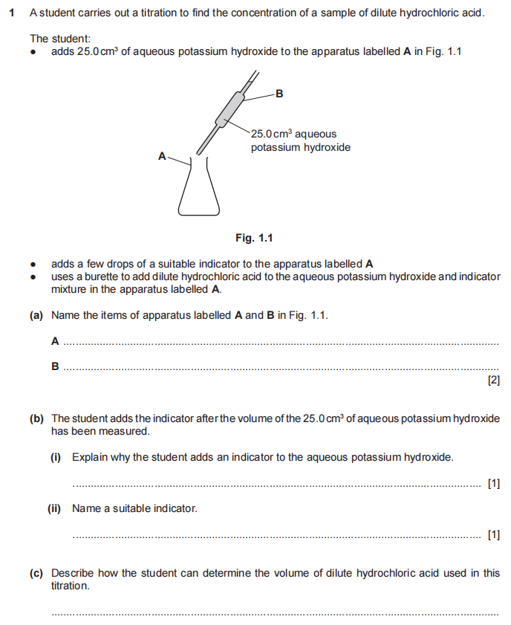
1.

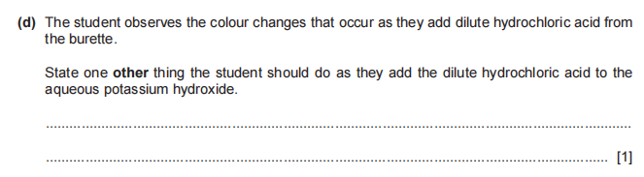
2. The graph shows the change in the pH when aqueous potassium hydroxide is added to 25.0 cm³ of dilute nitric acid to form a solution of potassium nitrate.
A pH meter was used.
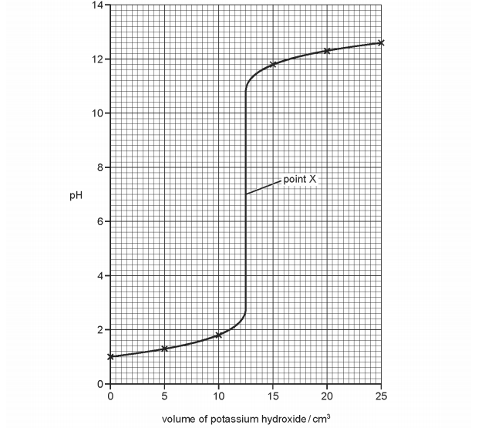
(a)Name a suitable apparatus to measure 25.0 cm³ of dilute nitric acid..
....................................................................................................................[1]
(b) What could be used instead of a pH meter in this experiment?
....................................................................................................................[1]
(c) Describe how the pH of the mixture changes as the potassium hydroxide is added.
....................................................................................................................
....................................................................................................................[2]
(d) (i) What has happened at point X?
....................................................................................................................[1]
(ii) What volume of aqueous potassium hydroxide had been added to the mixture
at point X?................................................................................................... [2]
(iii) What conclusion can you draw about the concentrations of the dilute nitric acid and the aqueous potassium hydroxide? Explain your answer.
....................................................................................................................
....................................................................................................................
....................................................................................................................
....................................................................................................................[2]
3. A student investigated the reaction between two different solutions of dilute HCl, A and B, and solution C which is alkaline.Two experiments were carried out
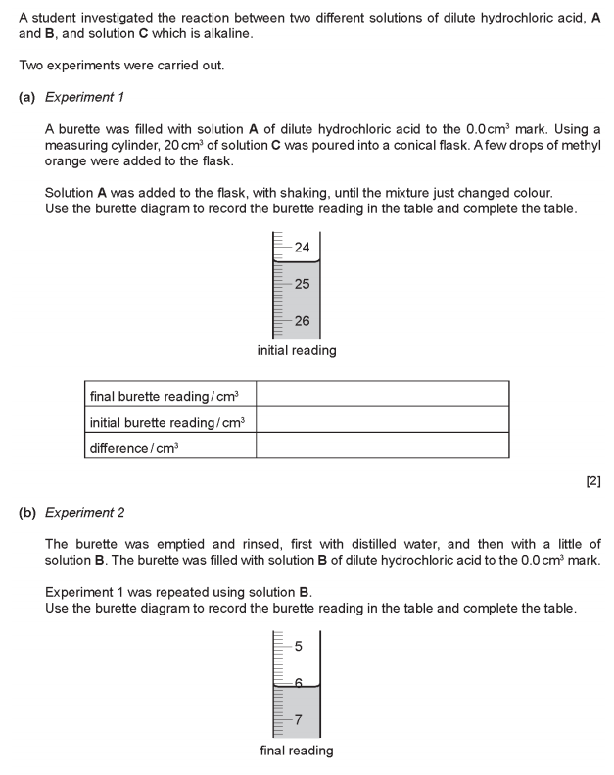
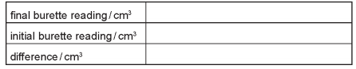
(c) (i) What type of chemical reaction takes place when hydrochloric acid reacts with alkaline solutions?................................................................................................... [1]
(ii) Why is methyl orange added to the flask?......................................................... [1]
(d) Why was the burette rinsed, first with distilled water and then with solution B, before starting Experiment 2?..................................................................................
.................................................................................................................................[2]
(e) (i) In which experiment was the greater volume of dilute hydrochloric acid used?
.................................................................................................................................[1]
(ii) Compare the volumes of dilute hydrochloric acid used in Experiments 1 and 2
................................................................................................................................ [1]
(iii) Suggest, in terms of the concentration of solutions A and B, an explanation for the difference in volumes used...........................................................................................
.................................................................................................................................[2]
(f) If Experiment 2 was repeated using 10 cm³ of solution C, what volume of dilute hydrochloric acid would be used? Explain your answer............................................
................................................................................................................................. [2]
(g) Give one advantage and one disadvantage of using a measuring cylinder for solution C.
advantage ....................................................................................................................
disadvantage ....................................................................................................... [2]

4. Many window-cleaning products contain aqueous ammonia.
Aqueous ammonia is an alkali that reacts with dilute acids.
Plan an investigation to find which of two window-cleaning products contains the most concentrated aqueous ammonia.
Include in your plan:• the method you will use•
how your results will be used to determine
which window-cleaning product contains the most concentrated aqueous ammonia.
You are provided with an aqueous solution of the two window-cleaning products, dilute hydrochloric acid of known concentration and common laboratory apparatus.
.................................................................................................................................
.................................................................................................................................
.................................................................................................................................
.................................................................................................................................
.................................................................................................................................
.................................................................................................................................
.................................................................................................................................
................................................................................................................................. [6]

